2025 BUSINESS of the Year Awards
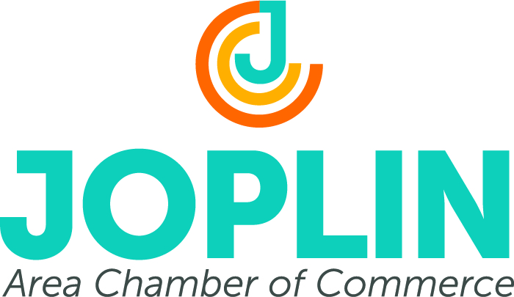
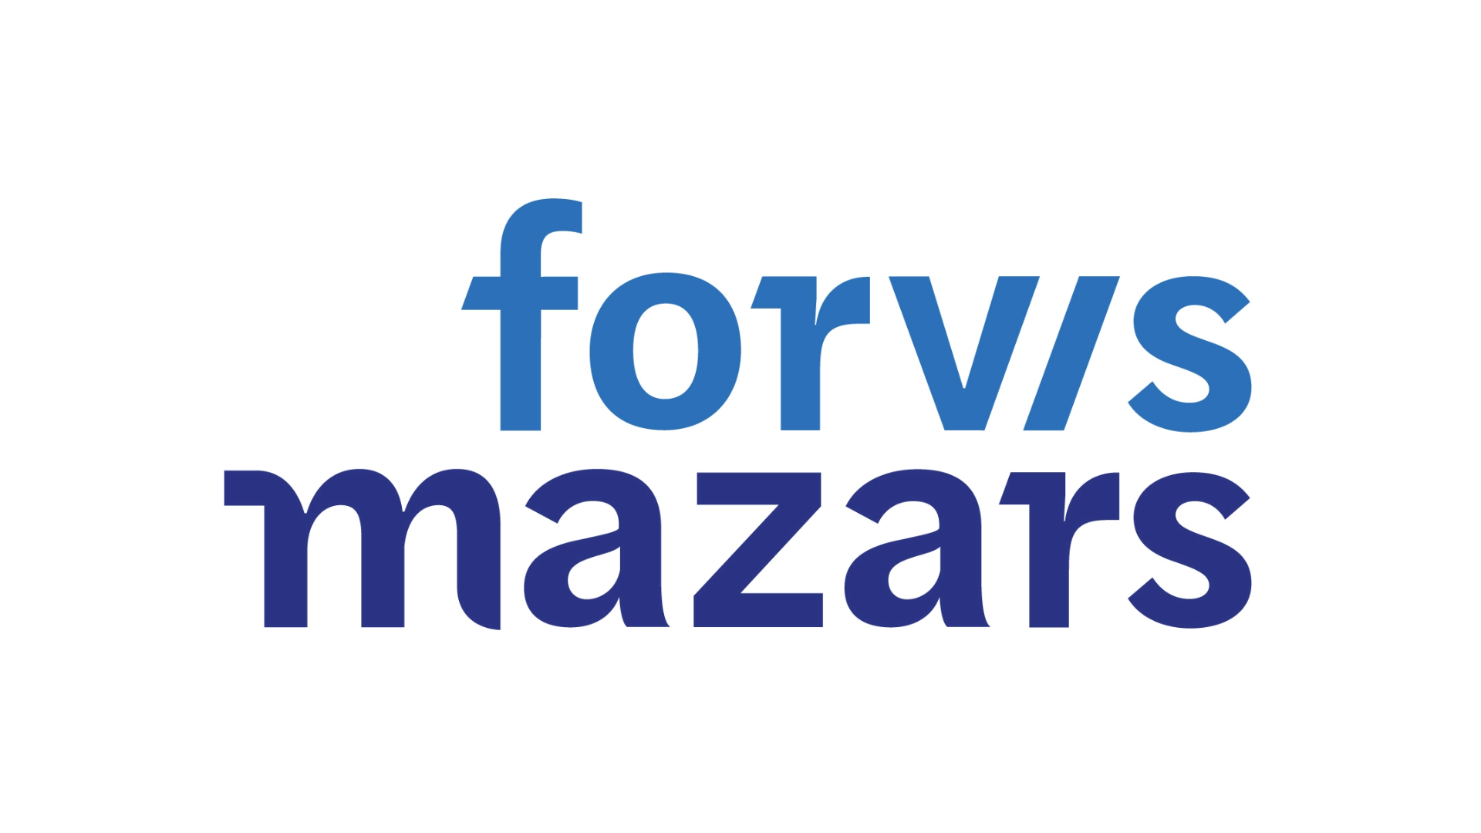

This is your opportunity to nominate a business or a not-for-profit business for the 2025 Business of the Year Awards presented by Forvis Mazars and the Joplin Area Chamber of Commerce. The awards recognize the contributions of all businesses to the local economy and to the overall progress of the Joplin area.

Awards will be presented to three (3) deserving businesses serving our community — one business employing 1-50 employees, one business employing 51+ employees and one not-for-profit business. Nomination forms are due February 28, 2025.

Requirements for nomination:
- Must be in good standing with the Joplin Area Chamber of Commerce
- Must have been a member of the Joplin Area Chamber of Commerce for two years
- Previous winners from 2020 or earlier are eligible for this award

Finalists will be chosen based on the following criteria:
- Contributions to the community
- Business or management philosophy
- Response to challenges
- Innovative products or services
- Employee involvement/recognition
I wish to nominate the following business for the Forvis Mazars 2025 Business of the Year Award:

Company Name___________________________________________________

Owner/CEO______________________________________________________

Please explain why your nominee is outstanding in this community. You may submit additional support material such as news articles or testimonials with your nomination.
_____________________________________________________________________________________

_____________________________________________________________________________________

Submitted by ____________________________________ Date ____________________________

Address ________________________________________ City/State/Zip _____________________

E-mail_________________________________________ Phone ___________________________

Mail or E-mail your nomination to:
Business of the Year Award
Joplin Area Chamber of Commerce
320 East 4th Street
Joplin, MO 64801
E-mail: stephanie@joplincc.com,
Or contact Stephanie McGrew at 417.624.4150

